Bayesian Classification Worksheet

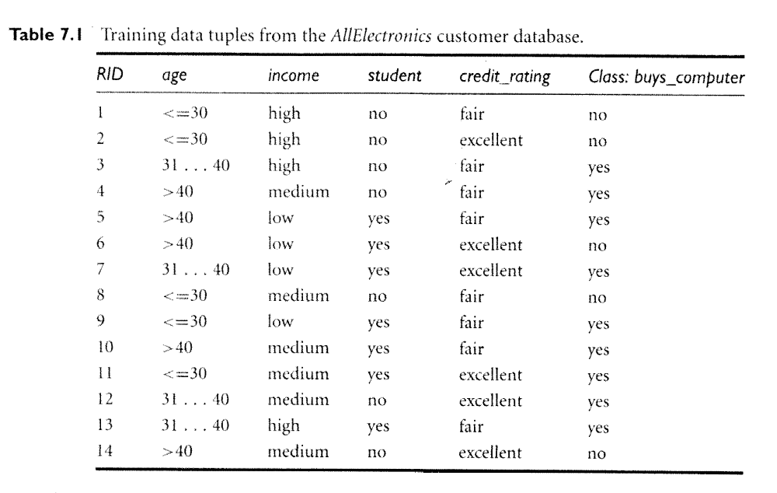

- (By hand) Leave the first four samples out, and then use the remaining 10 samples to calculate the probability that each of the first four samples buys a computer. Use the naïve Bayes classifier that we have been discussing in class.
- Create a notebook called bayes.ipynb. Link to .md file using jupytext in the command section of jupyter lab (see video). Using what you learned in 3.1 and 3.2, replicate your work using pandas. Add comments and write-up as necessary. If we can’t follow your calculations, we can’t grade your work.

